Customer NameDocument Title

INTERNAL
: Resorts World at Sentosa Pte. Ltd.

RWS
TECHNICAL SPECIFICATION – INTERFACE

S2P-I-017 TS for Exchange Rate Interface

Contents
1 Document Organization 5
1.0 Document Log 5
1.1 Integration, Document Reference 5
2 Clean Core Compliance 6
3 Program Attributes 6
3.1 Selection Parameter / Filter 7
3.2 Validation 7
3.2.1 Selection Criteria validations 7
3.2.2 Interface parameter validations 7
3.2.3 Other validations 7
3.3 Authorization Requirements 8
3.4 Definition 8
3.5 Defined Fields 8
3.6 Procedure 8
3.7 Technical Flow Diagram 8
3.8 Processing Logic 8
3.8.1 Validation 8
3.8.2 Mapping 8
3.8.3 Error Handling 8
3.8.4 Custom DDIC Objects 8
3.8.5 Custom CDS View Entity Details 8
3.8.6 BRF+ Design 9
3.9 Reusable Code 9
3.10 File Attributes 9
3.11 Internal Tables 9
3.12 Messages 10
3.13 Selection Text 10
3.14 Text Elements 10
3.15 Subroutines 10
4 Interface List Output 11
4.1 Field Details 11
4.2 Layout 11
4.3 Interface List Header & Footer 11
5 Application logs/Monitoring 11
6 Assumptions in Technical Design 11
7 Open Issues in Technical Design 11
8 Unit Test Results 11
9 Related Documentation 11

Document Organization
This section provides details about this document, previous version(s) of this document and the document(s) referred.

Document Log
Following table mentions the version changes and the processer(s):
Version | Status | Date | Version Created by (Name/E-Mail/Company) | Role | Comments
1.0 | Draft | June 24, 2025 | Ridhima Aggarwal | Author | Initial Draft
 | Choose an item. | Click here to enter a date. |  | Choose an item.

Integration, Document Reference
N/A
S. No. | Referred Document Name | Referred Document Version | Referred Document URL (Optional)

Clean Core Compliance
N/A
Final Solution | Category | Comments
 | Choose an item.

Program Attributes
Program title | ZGW_MM_EXCGRT
Program Name | ZGW_MM_EXCGRT
Program Type | ODATA API
Package | ZMM
Authorization Group
Type of Interface | Synchronous
Mode of Execution | Online

Transaction Code
Include Programs
Function Modules
Message Class

Classes
Generic Classes / Utility Classes
AMDP Classes
Proxy Class
FEH action class
Basic IDoc type
IDoc extension
Custom IDoc segment(s)
AIF Function module
API Name
CDS Name
Behavior Definition
Behavior Implementation Class
Service Definition
Service Binding

Selection Parameter / Filter
N/A
Single Valued / Range | Mandatory | Value Help | Default Value | User Text

Validation
N/A

Selection Criteria validations

Interface parameter validations

Other validations

Authorization Requirements
N/A

Definition
The purpose of this document is to Send Currency exchange rate information to eCSS / CSMS system via API call.
This document will provide / guide us on the Data mapping of tables and fields for the development and implementation processes to and to ensure the system meets the business requirements and integrates seamlessly with the existing workflows.

Defined Fields
N/A

Procedure
- eCSS system will request for rate via API call.
- CPI will Request the same data from S4HANA by calling ODATA API ‘ZGW_MM_EXCGRT’.
- ODATA will send back the exchange Rate as Response to CPI.
- CPI will send the Data in XML format to eCSS.

Technical Flow Diagram
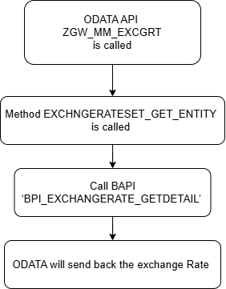

Processing Logic
- ODATA ZGW_MM_EXCGRT will be called to send the Exchange Rate to Sub System.
- Below is the Entity structure created for ODATA.
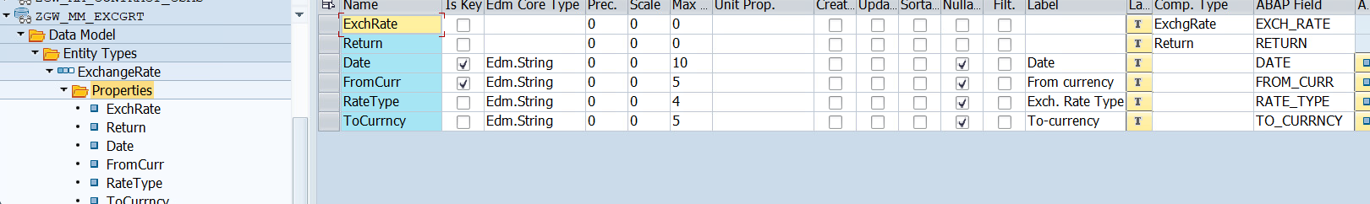
- Method ‘EXCHNGERATESET_GET_ENTITY will be called by GET query from CPI containing value of Date and FROMCURR.
- Fetch RATE and TOCURR from TVARVC where NAME = ‘ZMM_EXRATE_TYPE’ and ‘ZMM_EXRATE_TOCURR’ respectively.
- Call BAPI ‘BPI_EXCHANGERATE_GETDETAIL’ and fetch exchange rate and file the fetched data in EXCHRATE field of entity.

Validation
N/A

Mapping
N/A

Error Handling
N/A

Custom DDIC Objects
N/A

Custom CDS View Entity Details
N/A
Custom CDS entity Name
Primary View
Associated Views

BRF+ Design
N/A

Reusable Code
N/A

File Attributes
Same details mentioned in corresponding CPI Document.
File Type | Excel, ASCII, etc.?
Delimited / Fixed width | Comma, tab?
Header Record? | Provide layout
Footer Record? | Provide layout
Number of File Layouts and Description
File Layout(s) | Complete one per file layout (i.e., one for header records and one for detail records):

Messages
N/A
Message Class | Message ID | Message Text

Selection Text
N/A
Name | Description

Text Elements
N/A
Name | Text Description

Subroutines
N/A
Name | Description

Interface List Output

Field Details
N/A

Layout
N/A

Interface List Header & Footer
N/A

Application logs/Monitoring
N/A

Assumptions in Technical Design
N/A

Open Issues in Technical Design
N/A

Unit Test Results
N/A
Scenario # | Input Selection Criteria | Expected Result | Actual Test Pass/Fail
 |  |  | Choose an item.
 |  |  | Choose an item.
 |  |  | Choose an item.

Related Documentation
N/A

Template Version

Version | Status | Date | Version Created by | Reviewer | Approver | Comments
1.0 | Final | February 11, 2019 | Abhishek Nayak | Jagmeet Singh | Modak Gupta | Initial version created
2.0 | Final | Oct 18, 2023 | Ravish Ranka | Jagmeet Singh | Modak Gupta | Updates according to latest development guideline

